Now like any other algorithm there are few limitations to K-means++ also.

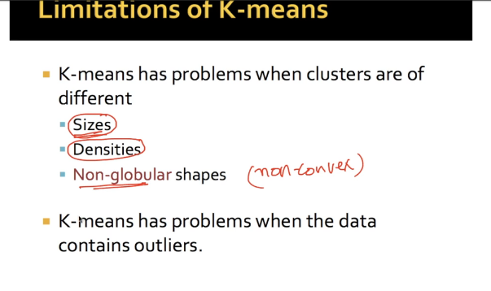

Now lets see what happens when we have clusters of different sizes.

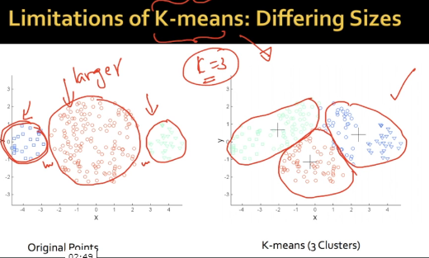

SO K-means prefer to produce clusters of similar sizes so the output clusters from K-means with k = 3 gives us clusters which are way different from original one.

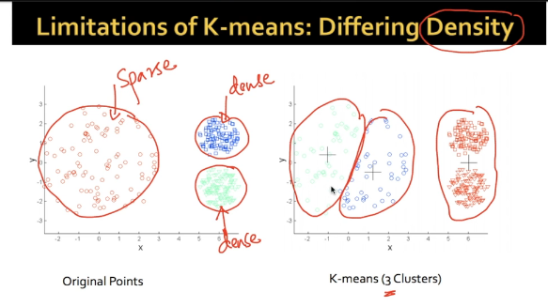

Now similar case is with different density i.e. no matter what your desity of cluster is k-means results in stretched cluster.

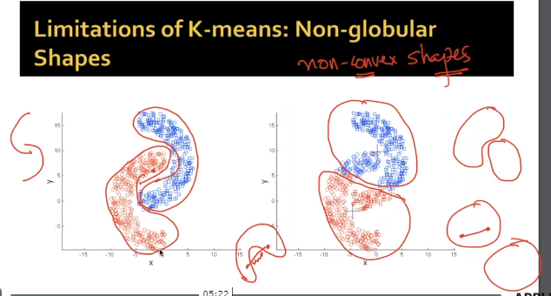

In case of Non - Gobular shapes or non-convex shapes we get different shape in output as original shape because k-means don’t understand this shapes.

NOTE: Non globular shapes are which if you travel from one point to another all the points in between way are of same set.

Now to overcome this problem for different sizes what we can do is increase value for K and then remerge those small cluster to get a bigger cluster which is not a full solution but only solution yet.

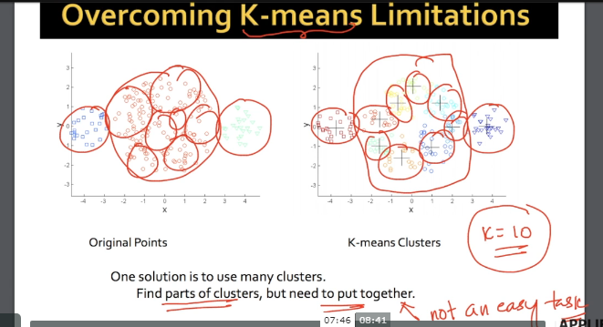

How to determine value for k will be discussed later.

Similarly we can do this for density problem and globular shape also.

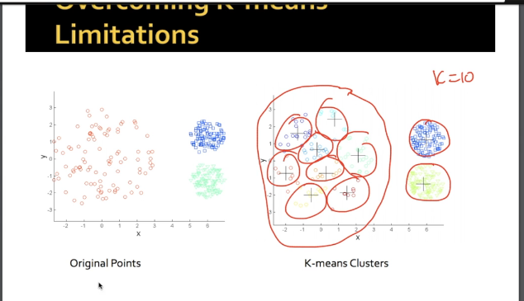

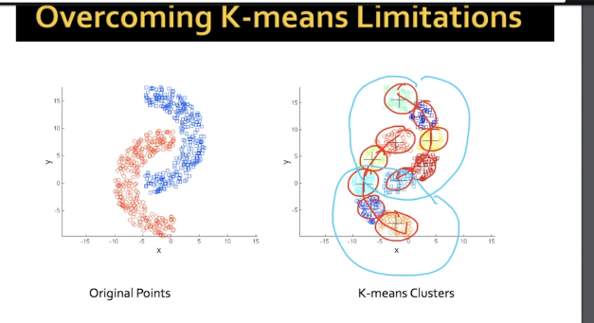

Now K-means may not be perfect solution but it very good as we do not have any y

And just talking about evaluating clusters i.e. intracluster or intercluster.

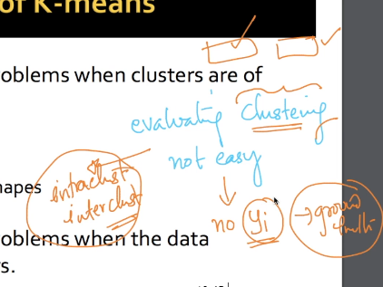

**Comments:**

No commets